How Smart Are Buildings Today? / Traditional vs. PIBCV Technology

Nowadays high-tech world flood us with more and more „smart” devices (smart phone, smart watch, smart washing machine, smart …). This trend has reached the HAVC sector. We hear more and more often about smart thermostats and smart homes. What makes a device smart? Most often, simply it is able to communicate with other devices (many mistakenly thinks that smart phone or peripheral devices – sensors, etc. can be connected to it, or it is programmable). The latest smart device of HAVC sector is a valve actuating motor (used in water-based cooling/heating systems), which can be installed on the AB-QM valve (PICV – Pressure Independent Control Valve) made by Danfoss, and this motor is called NovoCon® (Fig. 1.).
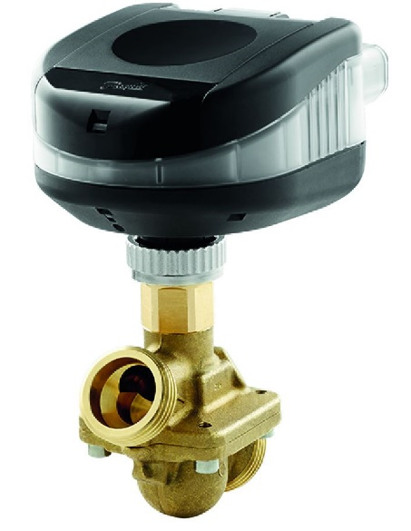
1.ábra
Valve Actuators are used nowadays as simple executing devices, which are usually controlled from a Building Management System (hereinafterBMS). In practice this

means one-way communication – systems are pretty rare, where active feedback is provided. By contrast, the NovoCon enables full two-way data sharing and can provide direct connection to a computer – omitting so called Room Controllers (RC). (Fig. 2.) By raising technical level, the NovoCon basically include four function: 1) Bus communication with the BMS through BACnet or ModBus language, 2) peripheral devices (I/O) can be directly connected to it, 3) flow indication and energy metering, 4) through collected dataperforms energy management, predictive maintenance.
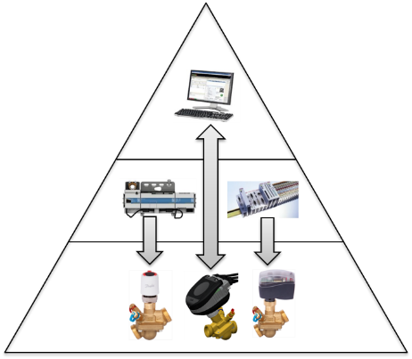
Fig. 2.
A key feature of NovoCon is that using remote control, multiple tasks can be carried out through it, so there is no need to „visit” the control valve to perform certain interventions (Fig. 3).
- Planned flow rate setting – no need for physical intervention – maximum flow is limited digitally
- System flushing – if heating/cooling medium contain a great deal of impurities and the control valve gets clogged, then valves of the system can be opened simultaneously or possibly sequentially, thereby ensuring removal of impurities from within the valve.
- Venting – there may be an increase of trapped air in a radiator – removing it is always difficult. The air venting function of the NovoCon opens and closes the valve five times in a row with the highest actuating speed (3s/mm), with which action it can most likely “pump out” air and the radiator can operate again with maximum power.
- Alarm, warnings – thanks to two-way communication, the operator receives signals on system operation. Just as an example, if a valve fails close – because dirt gets between the valve seat and cone – then it sends an alarm that it is desirable to perform a valve flushing.Another example is that any fault in motor wiring (wire break) is also signalled, etc.

Fig. 3.
In practice this is extremely advantageous. In case of a conventional system filling up the system can be performed after valve installation, then at the next call comes presetting, motor installation and wiring, and finally suspended ceiling can be closed. With employing a NovoCon valve the valve installation, motor mounting and cable connection can be carried out in one step. Considering that there is no need to “visit” the control valve anymore, suspended ceiling can be closed, which means that building takeover can be significantly accelerated.
However, the question arises, how can you “breathe life” into the system, when the BMS system is not yet operational (Usually BMS system is „up and running” only after the building is put into operation.). In case of a NovoCon system, there is a possibility of pre-programming actuators with a „Configuration tool” software (+cable), with which parameter settings can be uploaded through a laptop computer. (Fig. 4.)
It is important to note here, that in this case there is no need to attend the motors one by one. Motor groups connected to the network (All actuators of the group) can be programmed from one place for the group.
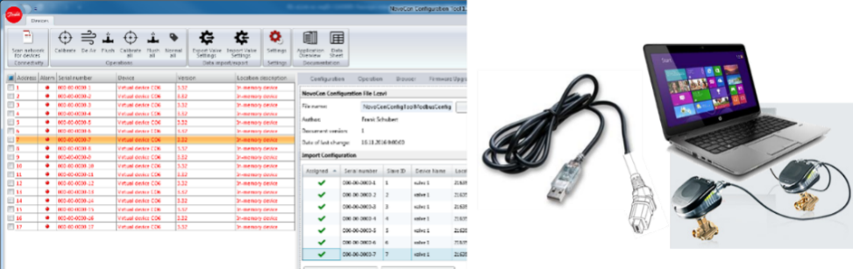
Fig. 4.
During this dynamic, fast development time, if anyone is asked what is the most expensive in this business, the answer almost without exception is TIME. Therefore, the time used for installing and commissioning such systems must be as short as possible. The NovoCon actuator can contribute to this the following ways:
- Automatic protocol detection – the actuator itself sets network language (BACnet or ModBus)
- Automatic addressing – the system automatically allocates network addresses, there is no need for lengthy manual address setting, for example, through DIP switches(BACnet)
- Auto Parity detection (Modbus)
- Automatic baud rate setting – the motors detect the speed of network traffic – there is no need to deal with this setting
- Remote control – remote access enables us not to visit the actuator so many times
- Motor and wiring checking – it is detectable where excessive voltage drop, broken wire, connection fault, etc. is located, thanks to active feedback.
- Different alarms – provide information on the network status thereby reducing troubleshooting time.
- Daisy chain wiring – motors are wired together in a ring (max. 64 motors/loop) with prefabricated cables, so less cable with less lay down time is used
- Plug and Play cables – cable termination plugs fit NovoCon sockets lowering the cost of electric installation.
Some of cables used enable direct connection of peripheral devices to NovoCon. So, there is no need to wire these devices separately and to connect to RCgenerally used. Signals received from these devices get directly to BMS through the NovoCon. Such devices are temperature sensors (PT1000), any Inputs/Outputs (I/O) with 0-10V signals and digital signals as well.
Two thermometers can be connected with a so called I/O cable furthermorean input and an output with 0-10V signals(Fig. 5.). This 0-10V signal, however, can be converted to digital signal through a multiplexer, thus a 0-10V input/output can be converted up to 4x digital input/output. At the same time, temperature inputs can also be used as digital signals. Often having a heating/cooling system with four pipes
means employing two actuators. In this case two I/O cables can be used for connecting different peripherals, which is a huge variation of possibilities. Digital inputs most often used are windows open sensor, presence detector, humidity sensor, CO2 sensor; digital output can be fan speed control,
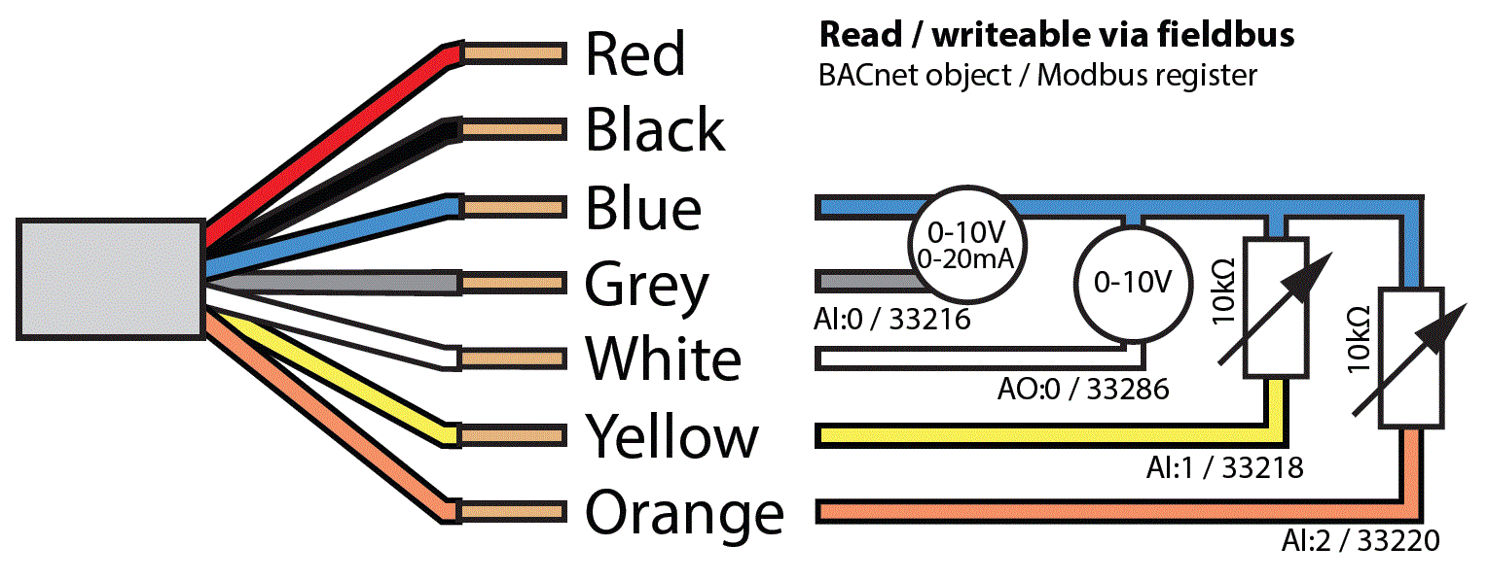
Fig. 5.speed,
shutter drive, lighting, etc. An analog input is, for example, a pressure signal for optimising pump operation. Examples of analog outputs are fan-, heat recovery unit- 0-10V control, etc., however applications are really limited by your imagination.
Let's have a look at an example of how to build a conventional control, and how does the arrangement changes, if NovoCon motor is used (Fig. 6.)
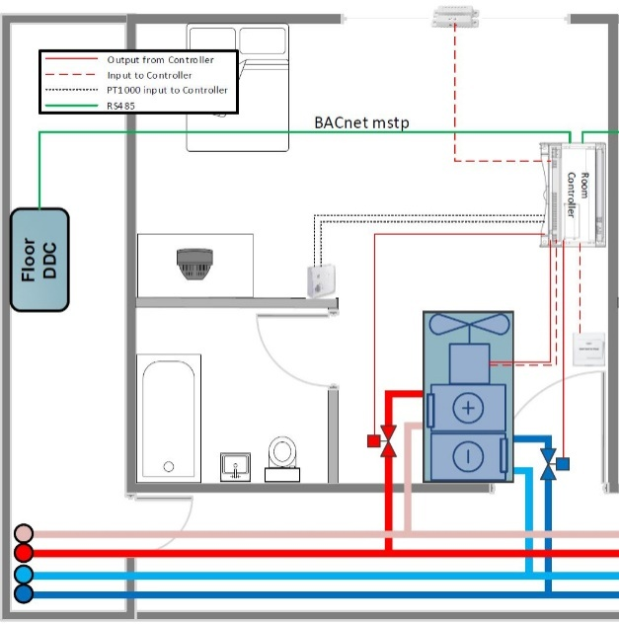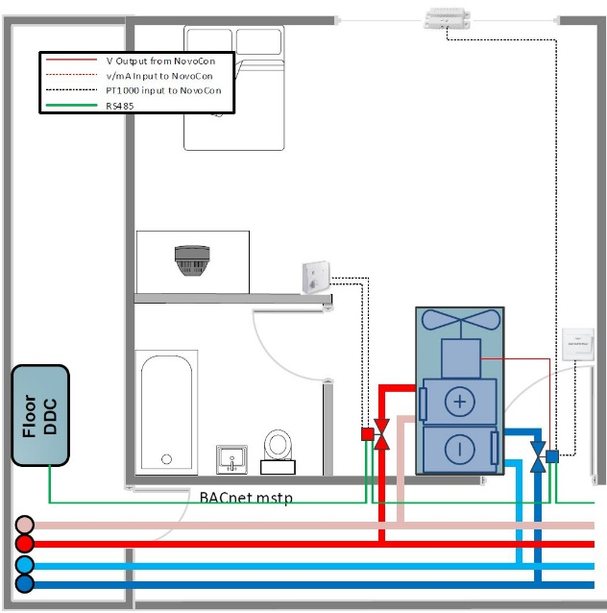
Fig. 6.
It is clear from this that – after connecting peripherals to NovoCon – there is no need for an RC. So, there is approximately 100€ savings on the hardware alone, not to mention other cost-cutting possibilities like wiring, labour cost, etc.
Can we save energy with smart actuators in addition to convenience services mentioned? The answer is a definite YES! If only the possibility of measuring energy consumption with NovoCon, and a cost splitting through measurement is taken into consideration, then there is approximately 10 % cost saving potential (10 % energy costs reduction is possible with introducing energy consumption measurement). In addition to this savings, there is approximately another 10% saving through using Energy Management.
Energy measurement can be performed by connecting two temperature sensors, as flow rate of the AB-QM (PICV) valve is determined by valve position (flow rate is determined by valve gap and is constant due to its pressure independence – the valve gap sets the flow rate). If the flow rate is known, difference in temperatures is measured, and then energy can be calculated for a known medium. This energy integrated versus time gives the energy consumption.
What is much more exciting is energy consumption optimisation. The NovoCon is capable of collecting data and performing intervention (valve movement) based on predetermined temperature demands. If it is required to limit return temperature or fix minimum temperature drop, then desired values can be set with a few keystrokes and the motor carries them out without any further programming. Fig. 7. shows an example of maintaining minimum temperature. It’s clear that if temperature difference falls below set value, the motor takes over the control from the BMS and starts to close the valve for reaching the minimum return temperature.
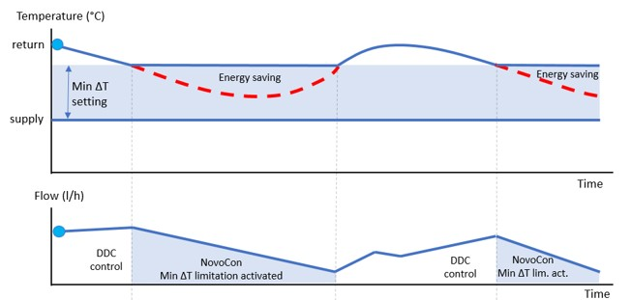
Fig. 7.
Fine tuning is also part of the energy management. Just to mention an example, flow rate data collected from a room (when and to what extent the valve was open) and temperature data (flow and return temperatures and their difference) and their differences from the desired values show signs of under/over sizing and show comfort features. Based on these figures, flow temperature, fan speed, control logic, timetable, etc. can be readjusted.
This function may have a major role in limiting peak load of the building and in determining the extent of energy reservation, which may results in further major cost savings (peak reservation fee).
And this can be further enhanced!
Nowadays proactivity is increasingly important. It is the best if a customer is always satisfied, feel comfortable, doesn’t even notice any fault “no downtime”. This can only be solved, if real time “preventive fault detection and maintenance” is performed. To do so, NovoCon can help with the following features:
- Continuously measures valve movement, and count cycles, which can be used to calculate required maintenance time (remaining lifetime).
- If a control valve gets stuck, sooner or later this results in complains, unless an alarm signal is received from NovoCon, that system flushing is required, which can be performed by remote control.
- Excessively high/low voltage level, or motor temperature feedback shows a fault of the electric system.
- ∆T monitoring helps in troubleshooting hydraulic faults (e.g. clogged filter, dirty radiator, etc.)
- The energy „counter“ reveals locations with too high / low energy consumption
- Alarm, in case of poorly installed actuator
Before embarking on an investment, it is worthwhile to perform a lifecycle costs study. Generally, difference in costs of investments with different technical contents is negligible compared to running expenses until the end of system lifetime (especially, if energy costs are considered too). Fig. 8. shows costs of a conventional system with and without PICV (shown in blue and red) valves compared to a NovoCon solution (shown in green).
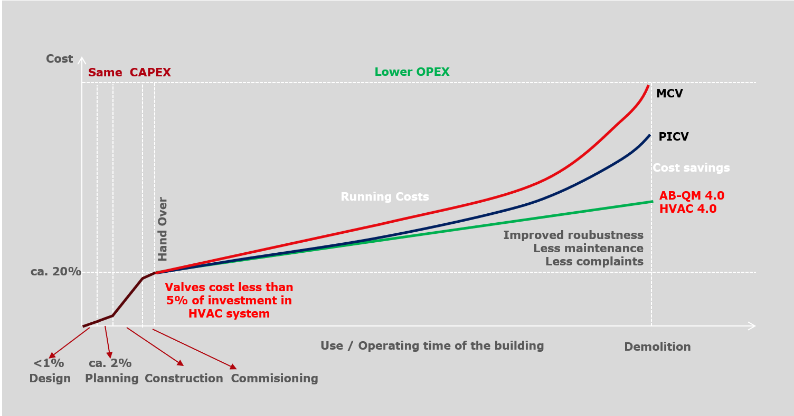
Fig. 8.
To sum up; Do not shrink back from the use of smart devices, even if their costs of devices is higher. The AB-QM + NovoCon actuator combination is ideal solution for comfortable operation with minimal energy consumption!
Székely Tamás / Danfoss A/S

